## 📝 Personal Task Management System
A secure, modern, full-stack personal task manager

## 📌 Project Overview
The Personal Task Management System is a secure, responsive, full-stack web application that allows authenticated users to manage their personal tasks efficiently.
Each user has private access to their own tasks with full CRUD functionality, ensuring data security and isolation.
This project demonstrates real-world backend authentication, authorization, and frontend-backend integration using modern technologies.
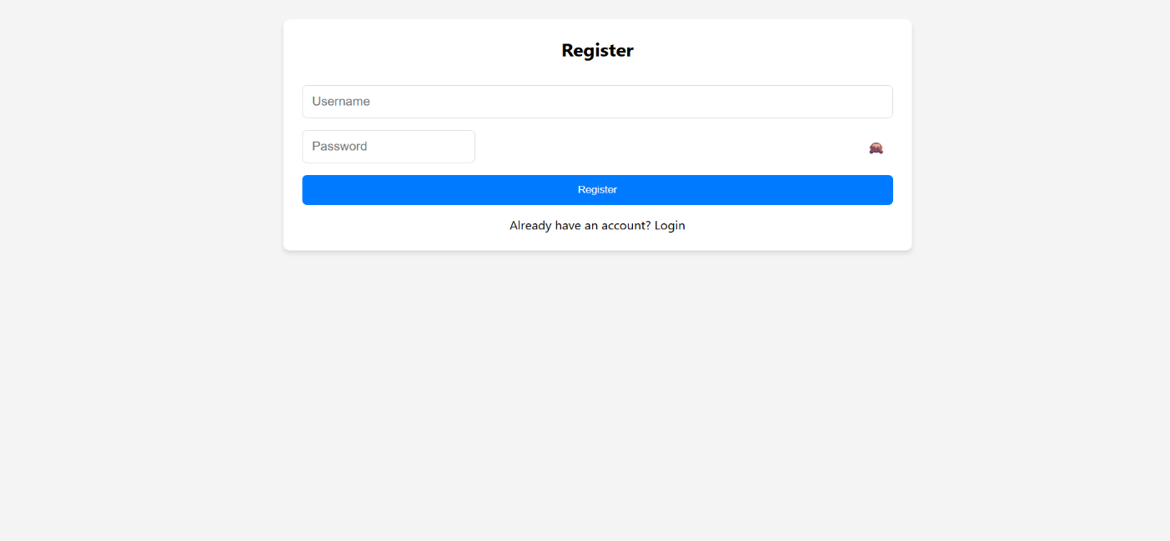
User registration page:
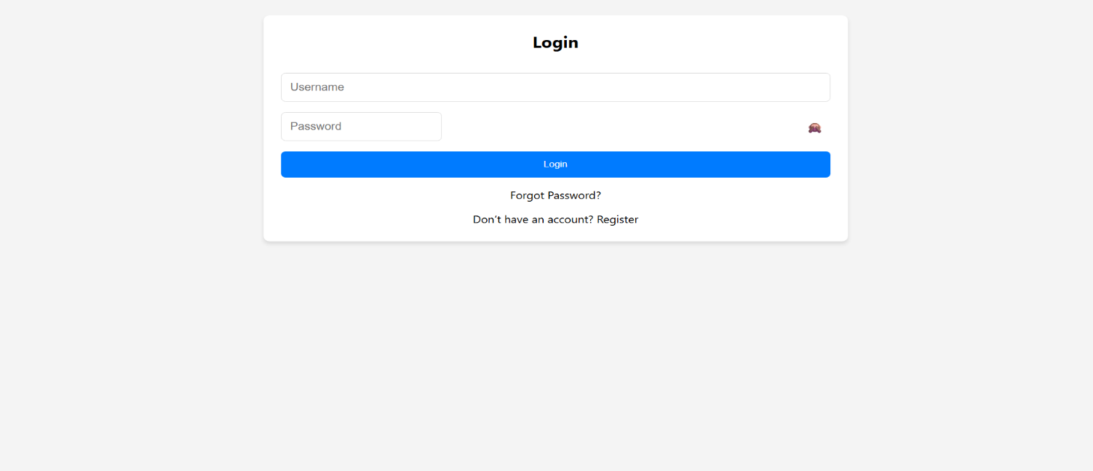
User login page:

User forgotpassword page:

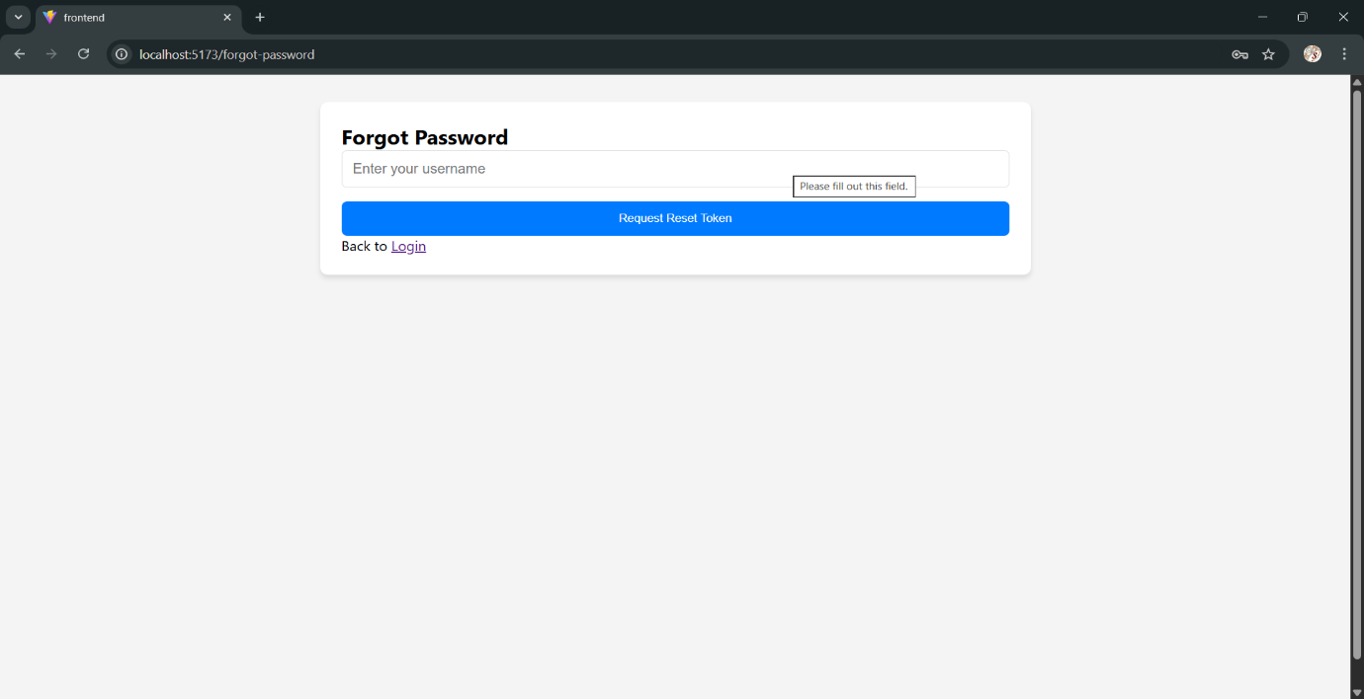

User interface after login :

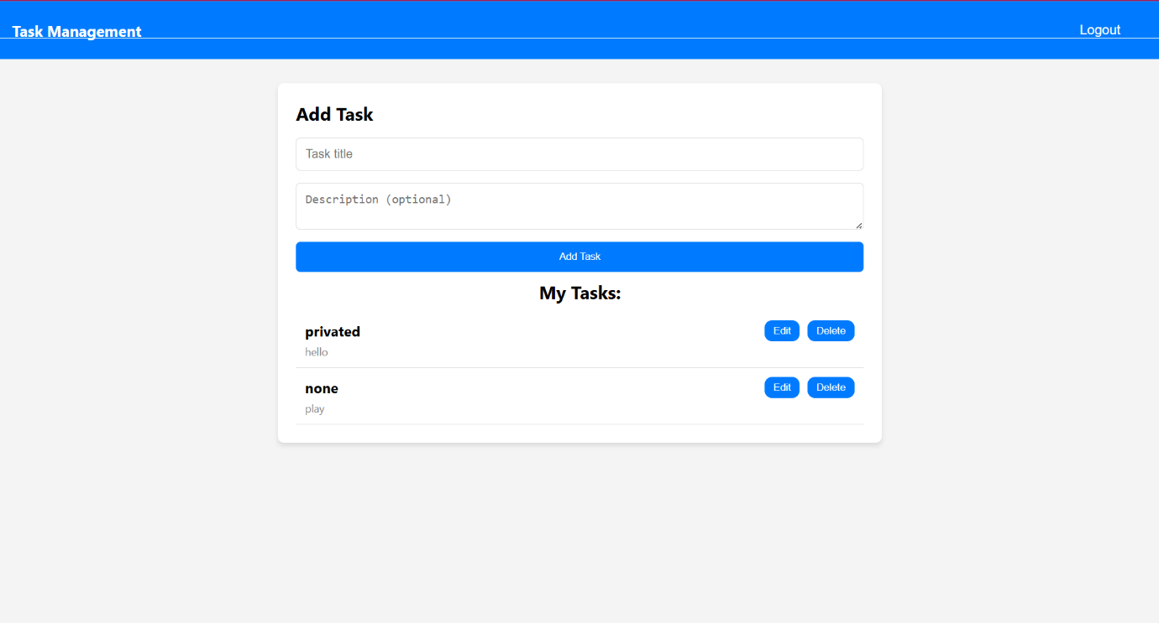
## ✨ Core Features
- ✅ User registration with secure password hashing
- 🔑 User login with JWT-based authentication
- 🔐 Protected routes accessible only to authenticated users
- 🔄 Forgot password functionality to request a reset token
- 🔁 Reset password using a secure, time-limited JWT token
- ➕ Create new tasks
- 📋 View user-specific task list
- ✏️ Edit existing tasks
- 🗑️ Delete tasks
- 🔒 Tasks are private per user (complete data isolation)
- 📱 Responsive and mobile-friendly user interface
- 👁️ Show / hide password option for better usability
- ⚠️ Input validation with clear and meaningful error messages
- ⚡ Fast development and optimized build using Vite
## 🧠 Task Status (Enhanced Feature)
Each task includes a status field:
- `pending` (default)
- `completed`
Users can mark a specific task as completed or revert it back to pending, improving task tracking and productivity.
Layer | Technology | Purpose
Frontend | React 18 + Vite 6 | UI & fast development
Routing | React Router v6 | Client-side navigation
HTTP Client | Axios | API communication
Styling | Plain CSS | Simple, customizable look
Backend | Node. js + Express | REST API server
Database | MongoDB + Mongoose | Data persistence
Authentication | JWT + bcrypt | Secure tokens & passwords hash
Environment | Dotenv | Configuration management

## 📂 Project Structure
task-manager-app/
├── backend/ # Node.js / Express server
│ ├── config/
│ ├── controllers/
│ ├── middleware/
│ ├── models/
│ ├── routes/
│ ├── .env
│ ├── package.json
│ └── server.js
│
├── frontend/ # React + Vite client
│ ├── public/
│ ├── src/
│ │ ├── components/
│ │ ├── App.jsx
│ │ ├── main.jsx
│ │ └── index.css
│ ├── .env.local
│ ├── vite.config.js
│ └── package.json
│
├── README.md
└── .gitignore

🚀 Quick Start (Development)
🔧 Prerequisites
- Node.js ≥ 18
- npm ≥ 9
- MongoDB (Local or MongoDB Atlas)
🖥️ Backend Setup
cd backend
npm install
Create .env file in backend/
PORT=5000
MONGO_URI=”your-mongoDB goes here”
JWT_SECRET=your-very-long-random-secret-min-32-characters
Start backend server
node server.js
✅ Recommended:
npm install -D nodemon
nodemon server.js
🌐 Frontend Setup
cd frontend
npm install
(Optional) Create .env.local
VITE_API_URL=http://localhost:5000
Start frontend
npm run dev
👉 Open in browser:
http://localhost:5173

🔄 Default Test Flow
- Register
  - Username: test333
  - Password: 123456
- Login
  - Copy the returned JWT token
- Create Tasks
  - Tasks are visible only to the logged-in user
- Update Task Status
  - Mark tasks as completed or pending

🔌 API Endpoints Reference :
Method | Endpoint | Description | Auth Required
POST | /api/auth/register | Create new user | ❌ No
POST | /api/auth/login | Authenticate & receive token | ❌ No
POST | /api/tasks | Create a new task | ✅ Yes
GET | /api/tasks | Get logged-in user's tasks | ✅ Yes
PUT | /api/tasks/:id | Update a specific task | ✅ Yes
DELETE | /api/tasks/:id | Delete a specific task | ✅ Yes

🔐 Security Notes
- Passwords are hashed using bcrypt (salt rounds = 10)
- JWT tokens are used for authentication
- Token validation via middleware
- Tasks are strictly scoped to the authenticated user
- No global or admin access implemented

🛣️ Future Enhancements (Roadmap)
- Task categories & priorities
- Due dates & reminders
- Multiple task statuses (To Do / In Progress / Done)
- Dark mode
- Search & filter functionality
- Drag-and-drop task reordering
- Export / import tasks
- Deployment (Vercel frontend + Render/Railway backend)

📄 License
MIT License
Feel free to use, modify, and distribute.

👤 Author
Kannuri Sindhuja
Hyderabad, India
📅 January 2026
Made with ❤️ using React, Vite, Node.js & MongoDB

